**Anatomy of Human Limb**

1. **Shoulder**

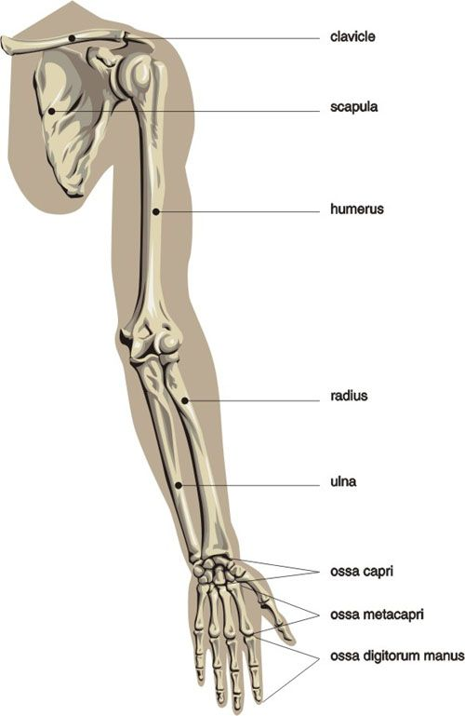

Human limb is divided into four main sections:

1. Shoulder Girdle
2. Arm
3. Forearm
4. Hands

**Shoulder** girdle consists of scapula and clavicle bone, **arm** consists of humerus bone, **forearm** consists of radius (on lateral side) and ulna bones (on medial side) and **hand** consists of carpals, metacarpals and phalanges.

The base of the hand contains eight bones, each called a **carpal bone**, and the palm of the hand is formed by five bones, each called a **metacarpal bone**. The fingers and thumb contain a total of 14 bones, each of which is a **phalanx bone of the hand**.

Standard view of limb is considered as supination position (palms facing upwards).

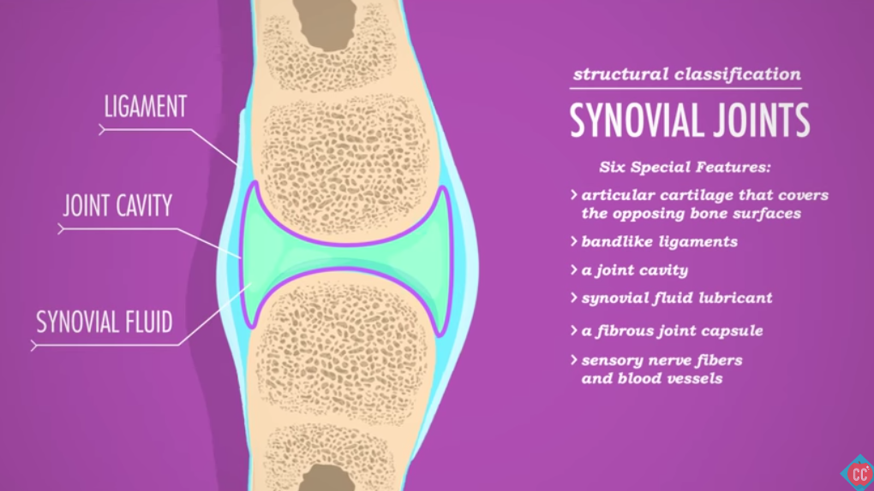

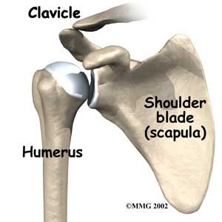**1.1** [**Shoulder Joint (Gelnohumeral Joint):**](https://youtu.be/vG1XQkj3Yx0)

Joint between shoulder (Scapula) and arm (Humerus) is a synovial (having space between the articulated surfaces) ball and socket joint. The articulated surfaces in the shoulder joint are the head of humerus and the shallow peer-shaped Glenoid cavity in Scapula. This joint allows motion in all three-dimensional planes. Adduction, abduction, motion in sagittal plane and circumduction is possible due to this joint.

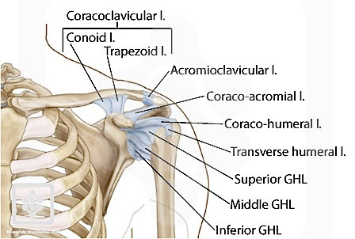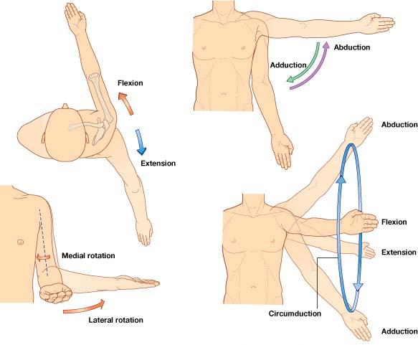

**Ligament** are the tough fibrous band of connective tissue that serves to support the internal organs and hold bones together in proper articulation at the joints. There are four ligaments associated with this joint:

1. Glenohumeral Ligament
2. Coracohumeral Ligament
3. Transverse Humeral Ligament
4. Coraco-Acromial Ligament

Position of each ligament can be seen in figure below.

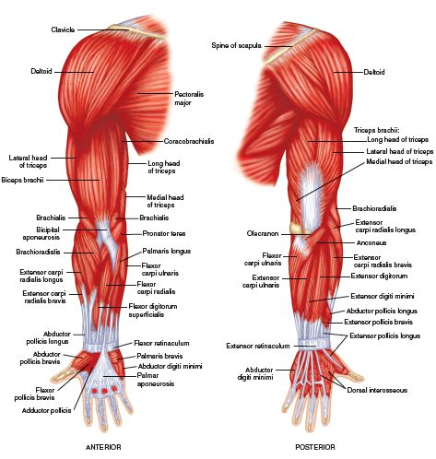

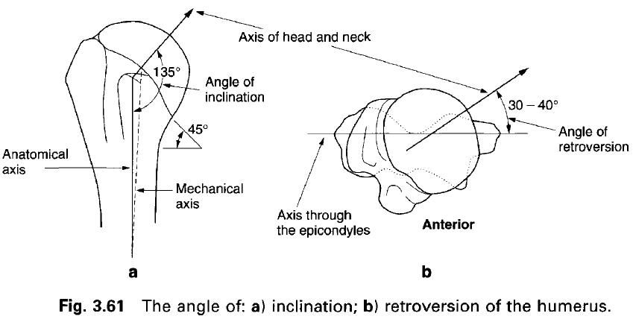

**1.2** [**Muscles**](https://www.youtube.com/watch?v=t1zJwD0tWck)**:**

(Also, watch: [Upper Limb Muscle Anatomy | 3D Anatomy with Actions of muscles, Forearm muscles, muscles of hand](https://www.youtube.com/watch?v=pSOa5UVv4sM))

The muscles contributing to the shoulder muscle joint motions are:

|  |  |  |  |  |
| --- | --- | --- | --- | --- |
| **Sr. No.** | **Muscle Name** | **Motion** | **Diameter** | **Length** |
| 1 | Teres Minor | Adduction, Lateral Rotation |  |  |
| 2 | Coracobrachialis | Adduction, Flexion |  |  |
| 3 | Subscapularis | Adduction, Lateral Rotation |  |  |
| 4 | Supraspinatus | Adduction, Medial Rotation |  |  |
| 5 | Infraspinatus | Adduction, Medial Rotation |  |  |
| 6 | Lateral Deltoid | Abduction |  |  |
| 7 | Anterior Deltoid | Abduction, Flexion, Lateral Rotation |  |  |
| 8 | Posterior Deltoid | Abduction, Extension, Medial Rotation |  |  |
| 9 | Biceps Brachialis | Flexion |  |  |
| 10 | Triceps (Long Head) | Extension |  |  |

[**Teres Minor**](https://www.youtube.com/watch?v=Zl-P3hgEJZg)

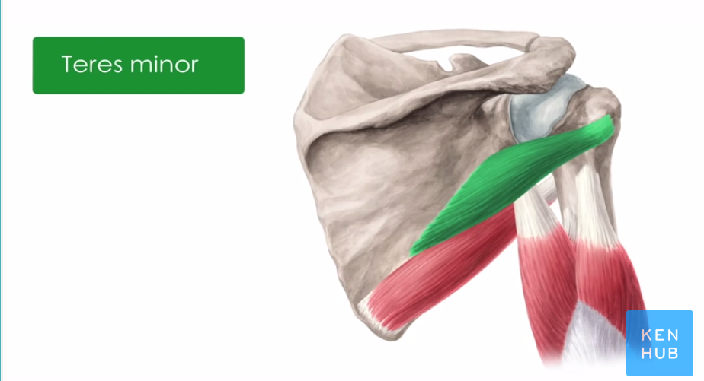

* Lateral Rotation of the forearm
* Adduction of the forearm

[Coracobrochialis:](https://www.youtube.com/watch?v=PB8Tcz3cAH0)

The contraction of the coracobrachialis leads to two movements at the shoulder joint:

* Flexion in the shoulder
* Adduction.
* Stabilizes the humeral head within the shoulder joint, especially when the arm is hanging freely straight down.

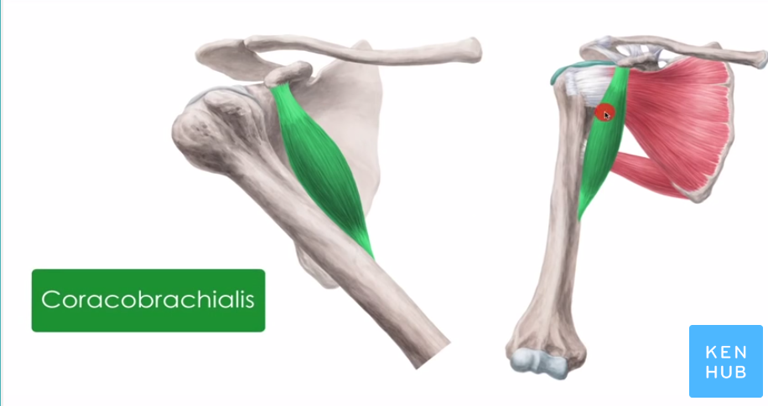[Subscapularis:](https://www.youtube.com/watch?v=vROvpEL6k14)

The subscapularis muscle is a powerful internal rotator which also supports the upper arm during abduction and adduction. Conversely, the teres minor muscle’s function consists primarily of external rotation, partly retroversion and adduction as well. The supraspinatus muscle performs abduction of the shoulder, especially abduction over 60 degrees. Finally, the infraspinatus muscle is a strong external rotator and additionally assists in both abduction and adduction.

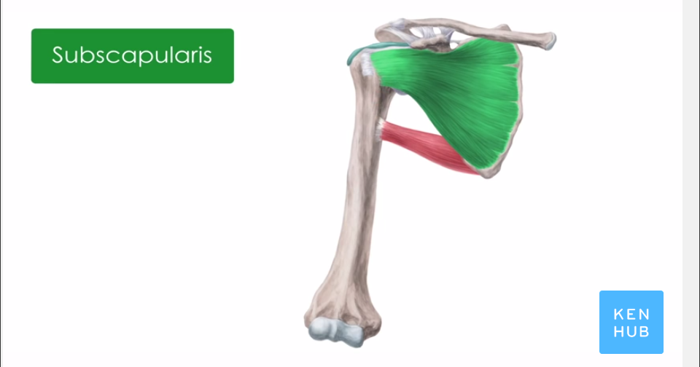

**Biceps Brachii**

* Flexion of the shoulder (long head).

When the other elbow muscles are balanced and elbow undergoes no motion, Biceps flexes the shoulder during contraction.

* Flexion of the elbow.
* Supination of the forearm.
* The supination is most powerful in a flexed elbow.

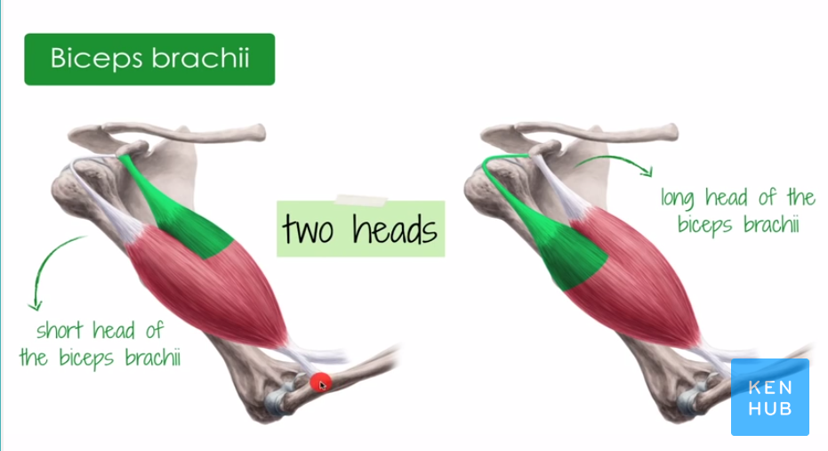

**Brachialis**

The brachialis is the strongest flexor of the [elbow joint](https://www.kenhub.com/en/library/anatomy/elbow-joint). It is even a stronger flexor than the biceps brachii, because it is closer to the joint axis and furthermore only stretches over one joint in contrast to the biceps brachii. A small contraction of the muscle consequently leads to a larger flexion in the elbow. Another function of the brachialis is helping with maintenance of tension found on the joint capsule, whereby it prevents damages to the capsule during hyperextension.

The Destral Group consists of:

* Anchoneous
* 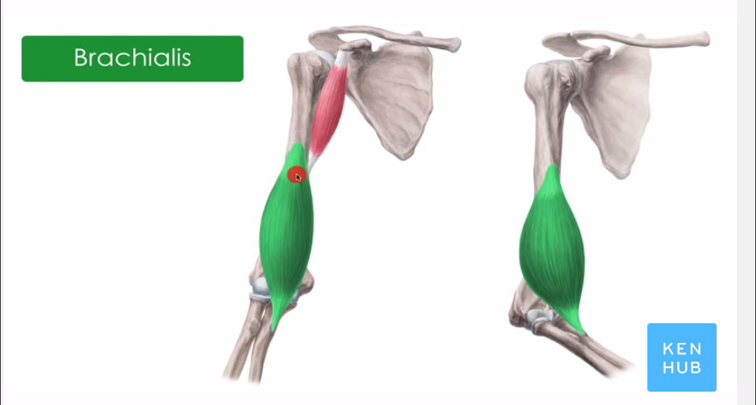Triceps Brachii

**1.2.4 Anchoneous:**

Functionally the anconeus fulfills the same tasks at the elbow as the triceps muscle. Its contraction leads to the extension of the forearm. Furthermore, it keeps the tension of the dorsal joint capsule, thus preventing damages during hyperextension. It is believed that the anconeus has the additional function of stabilizing the ulna, especially during pronation movements of the forearm.

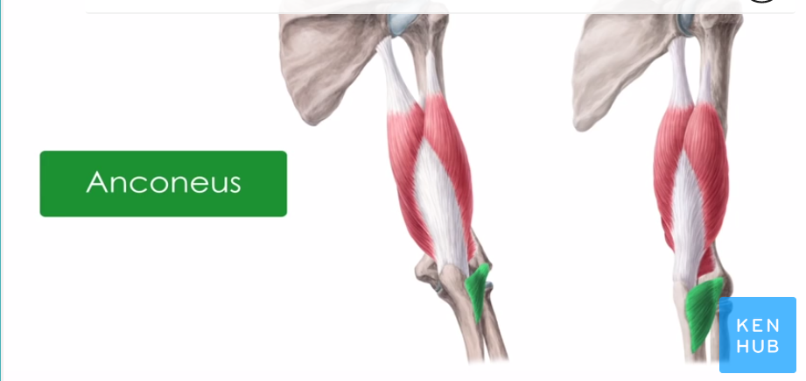

The muscles between Scapula and Humerus are:

* Coracobrochialis
* Teres Major
* Deltoid
* Rotator cuff

**1.2.5**

**1.2.8 Deltoid:**

The deltoid moves and stabilizes the shoulder joint. The movements of the different deltoid parts can interact both synergistically and antagonistically depending on the specific part and the position of the humerus. The deltoid is the most important abductor of the shoulder joint. The abduction is mainly initiated and held by the acromial part. Both the clavicular and spinal parts function as adductors up to 60° and abductors over 60°. Furthermore, the clavicular part causes an inward rotation and anteversion, the spinal part an outward rotation and retroversion.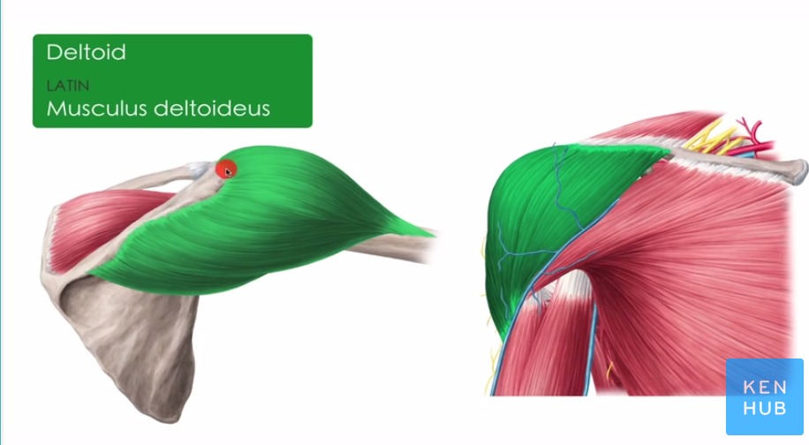

**1.2.9 Rotor Cuff:**

The Rotor Cuff consists of another three muscles:

* Subscapularis
* Infraspinatus
* Teres Minor

**Origin:** All the muscles originate from the Scapula and insert in the humerus.

The main function of the rotator cuff is to stabilize and center the humeral head in the joint socket, the glenoid cavity. In addition, the muscles tighten the joint capsule preventing a pinch during shoulder movements. Certainly, the rotator cuff – as the name suggests – plays a major role in the internal and external rotation of the upper arm in the shoulder joint. All the muscles mentioned above fulfill different functions.

**1.2.10**

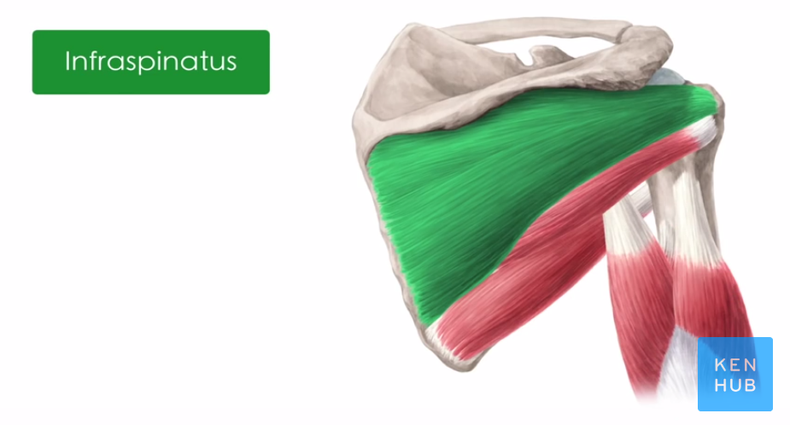

**Other contributing Muscles:**

* + 1. **Pectoralis Major Muscle (Left):**

The pectoralis major muscle is the most important muscle for the adduction and anteversion of the shoulder joint which is why it is also known as the “breaststroke muscle”. It rotates the upper arm outwards and makes a powerful stroke movement (retroversion) when the arms are elevated (e.g. in wood-chopping). If the arms are fixed the muscle lifts the trunk which can be helpful in climbing or during inspiration (inspiratory breathing muscle).

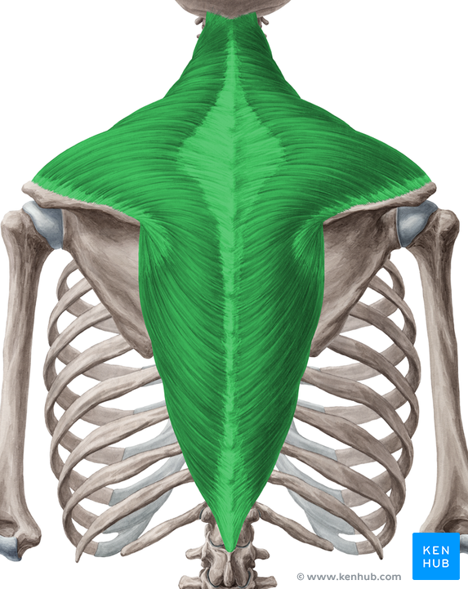

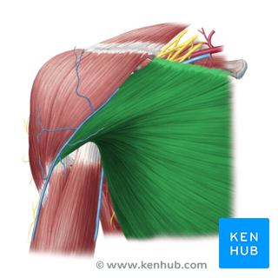

**1.2.12 Trapezius Muscles (Right):**

The trapezius stabilizes and secures the shoulder blade at the thorax and fulfills numerous tasks. It moves the shoulder blade medially and rotates it outward. In addition, the descending part causes elevation of the scapula while the ascending part depresses this bone. Furthermore, a unilateral contraction bends the head to the ipsilateral side (lateral flexion) whereas a bilateral contraction raises the head and the cervical vertebral column (dorsal flexion).

**1.2.13 Latissimus Muscle:**

The primary function of the Latissimus Muscle is the adduction of the arm, which is often used when performing a pull-up or chin-up or when pulling a heavy object down from a shelf above one’s head. Another function of the lat is extension of the arm, as in swinging the arm toward the back. This motion is used when swinging the arms while walking as well as during rowing exercises. Finally, the latissimus dorsi medially rotates the arm, moving the front of the arm towards the body’s midline. When performed with a bent elbow, medial rotation of the arm brings the hand towards the chest, like when folding the arms or touching the elbow on the opposite arm.

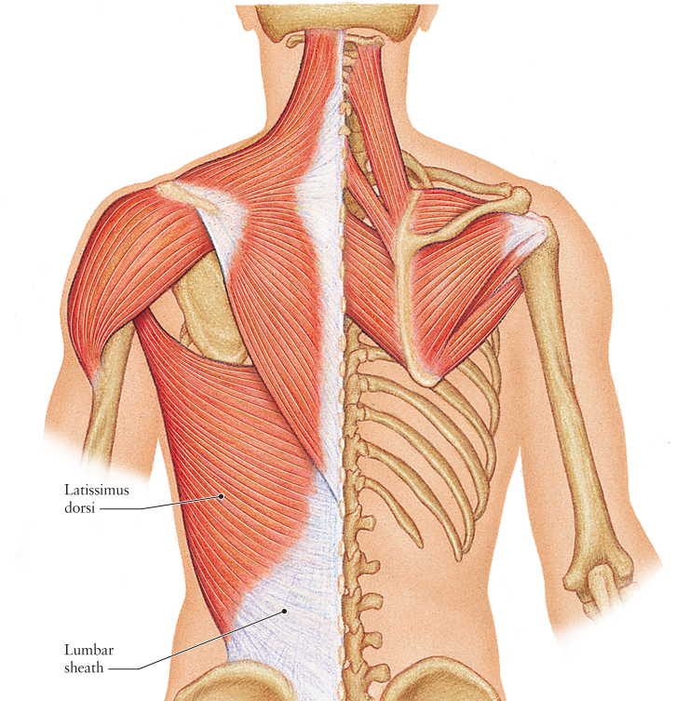

**2. Elbow**

**2.1** [**Elbow Joint (Synovial Hinge Joint):**](https://www.youtube.com/watch?v=3l3-5Ij3JZ8)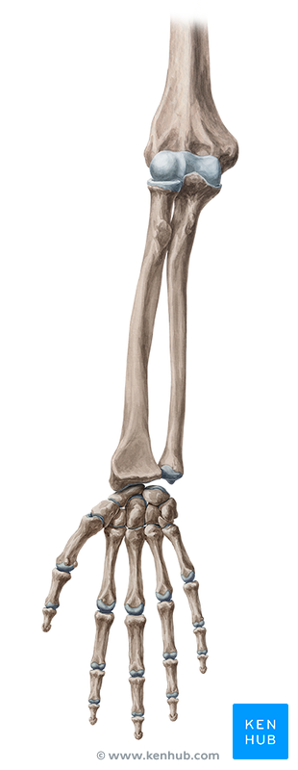

It’s a compound joint consisting of following sub- joints:

* Humerulnar joint (between Humerus and Ulna)
* Humeroradial Joint (Humerus and Radius)
* Proximal Rodioulnar Joint (Radius and Ulna)

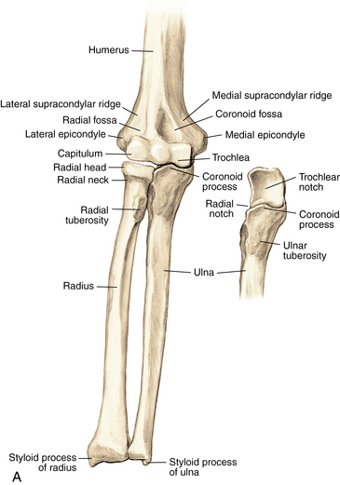

The Radius rotates about the Capitulum at the Radius head while the Ulna rotates about the Trochlea of the Humerus at the Troclear notch. The Extension and Flexion motions in Hinged Joint can be achieved.

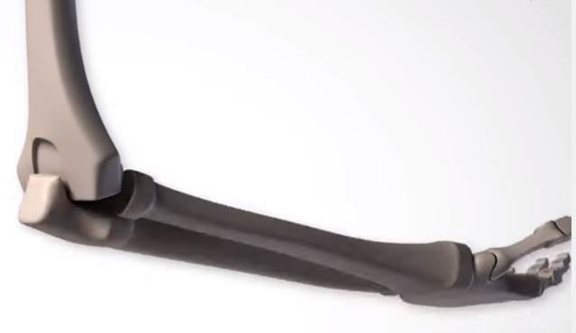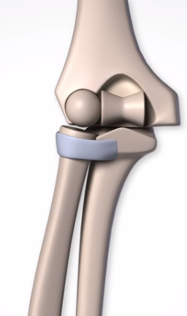

The Radioulnar joint is a pivot joint where rotation of Radius occurs about the Ulna supported by the the Annular Ligament.It results to Supination and Pronation movement.

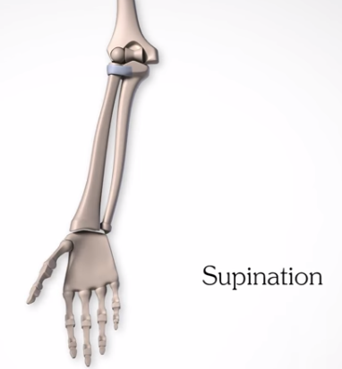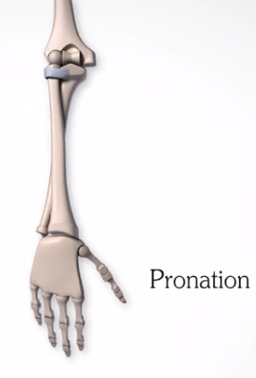

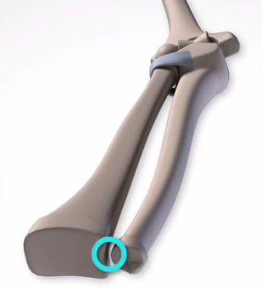

The Hinge joint at the Ulna prevents its rotation. Note that the Distal Radioulnar joint is also a Pivot joint as discussed later in hand Section.

The ends of the bones are covered by Articular (Hyaline) Cartilage. These are white, shiny, rubbery and slippery allowing the sliding motion. They absorb shocks and provide smooth motion between the joints.

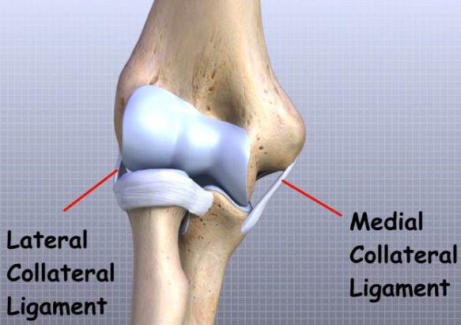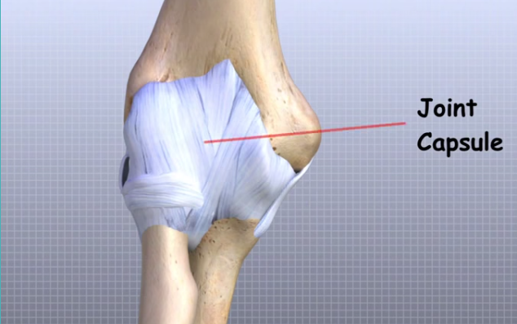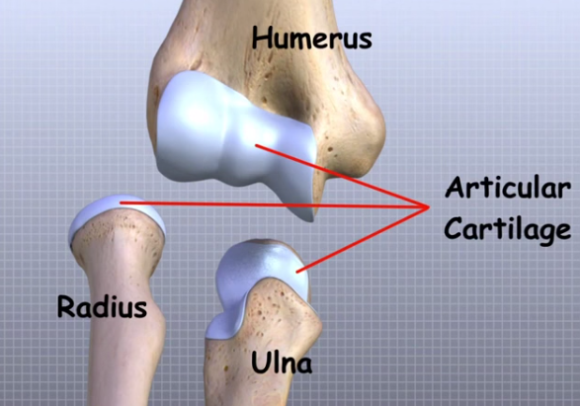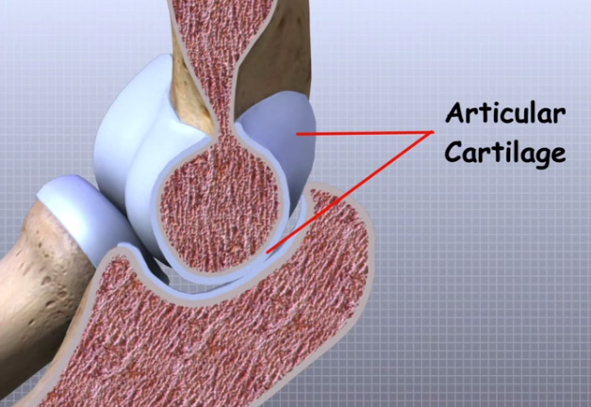

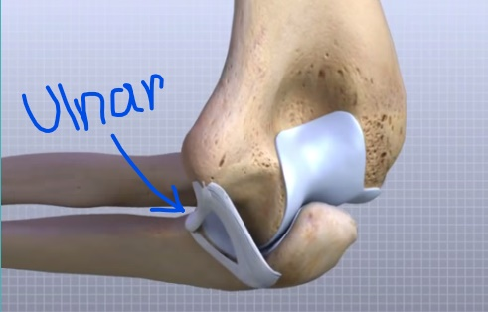

There are several ligaments in the Elbow joint connecting the bone to bone together. The main Ligaments are **Radial (Lateral) Collateral, Ulnar (Medial) Collateral and Annular Ligament**.

The ligaments around the joints relate to a thin layer of connective tissue forming a structure called as Joint Capsule. Joint capsule is a water tight tight sac containing the lubricant fluid known as **Synovial Fluid**.

**2.2 Muscles**

The muscles contributing to the Elbow motion are:

1. Brachialis
2. Brachioradialis
3. Pronator Teres

